D01 – Introduction

# Identification data

__4__ __3__ __https://github.com/rodddella/Acme-One/_________________________________  
Group Level GitHub repository

__Seville (Spain), 16/03/2021__________________________________________________________  
Place, date

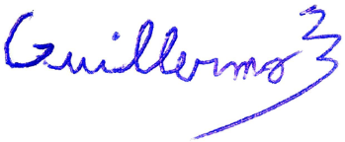__Guillermo Diz Gil (Manager, developer, tester)________________________________   
Student #1: Full name, roles, and signature

__Francisco Rodríguez Pérez (Developer, tester)________________________________  
Student #3: Full name, roles, and signature



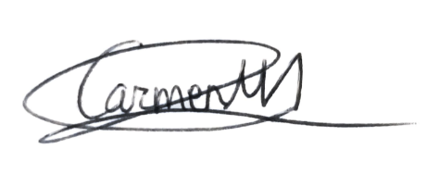__Carmen María Muñoz Pérez (Developer, tester)________________________________  
Student #2: Full name, roles, and signature

__George Laurentiu Bogdan (Developer, tester)________________________________  
Student #4: Full name, roles, and signature

# Responsibility statements

[X] I am an author of this deliverable. I have not cheated in any way.

[X] I have collaborated with my partners on producing this deliverable; in other words, neither have I ridden their coattails nor gobbled them up.

[X] I have learnt from working on this deliverable, so that I can pass my control check.

[X] I understand that my deliverable will be considered failed if I fail to meet any of its requirements or if I fail to submit it by the deadline.

[X] I understand that I must have a contingency plan and that submitting my deliverable very close to the deadline is likely to result in disaster.

[X] I have taken into account the guidelines provided in the lectures and document “On your deliverables.pdf”, which are available at the USE’s e-learning platform.

# Deliverable and requirements

## Requirements for level C

### Item 1: workgroup report

* Produce a report with the following contents:
  + Provide a cover with your workgroup number (sign up at the USE’s e-learning platform to get it), the member names, a table of contents, and a summary.
  + Describe how you have recruited the members of your workgroup.
  + For every member of your workgroup provide: contact data (surnames, names, corporate email account at the USE, and recent picture – no avatars or old pictures, please), a description of his or her roles, and an assessment of his or her performance.
  + A formal agreement in which you all commit to working together in this subject, declare that you have understood its syllabus, and commit to achieving a particular grade (A, B, or C). Note that the agreement must make it explicit that if a member does not perform adequately, he or she might be fired, in which case, he or she will fail the subject. It must clearly define what “not performing adequately” means. (Recall that earning an A+ is not a group, but an individual decision.)
  + The report must be dated and signed by every member of your team.

## Requirements for level B

### Item 2: development configuration

* Produce a report in which you comment on how you have set up your development configuration. Please, note that we are not asking you to reproduce the guidelines to set it up; we are asking you for a report in which you make it clear that you’ve followed the guidelines and have your development configuration ready to work. The structure of the report is up to you, but it is expected to be professional and homogeneous across the members of your workgroup.

## Requirements for level A

### Item 3: customising the starter

* Produce a version of the Starter Project called Acme One. Customise it according to the guidelines and modify the anonymous menu so that every member of the workgroup includes his or her favourite link. The text in the link must match the following pattern: “<surname>’s Link”, where “<surname>” denotes the surname of a member of your team; if your surnames are ambiguous, please, add your names; if the result is still ambiguous, please, add your National ID number. Note that the text in the link must be internationalised.